The 2025 Masters Tournament
What to say about this one. Since 2010 I’ve been cheering for Rory McIlroy. At first it was because he was a member of my fantasy team, but it quickly became more than that. I’ve always felt his swing is the most beautiful in the game of golf, though a case can certainly be made for Adam Scott and Louis Oosthuizen. In his early career he had a level of cockiness in his game. The effortless power was incredible to watch. You knew when he started to get that pop in his gait that he was firing on all cylinders. As his career has gone on, he’s shown a vulnerability that you rarely see with professional athletes, particularly golfers. They don’t like to let people in or show anything that might be perceived as weakness. Rory is different. Aside from his very public golfing heartbreaks, you never feel like he’s giving a PR answer, and truly tells you what he’s thinking, for better or worse. It’s come back to bite him on a few issues, but I think it’s something commendable from a professional athlete. One of the great storylines we get in golf is seeing someone finally reach the top of the mountain after years of hard work. That level of joy and relief is impactful. But I think even better, is when someone has reached the peak, fallen down the mountain, and has to climb back up again. To me, that’s the story of Rory McIlroy.

The Early Years
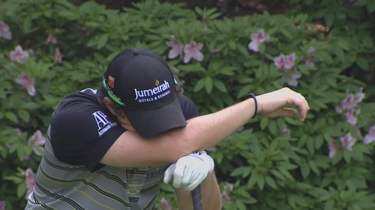
In the 2011 Masters, Rory faced the first major adversity in his career. Carrying a four shot lead into the final round, he wilted under the pressure, tumbling down the leaderboard to T-15. In an interview after the round, he was despondent. Despite that disappointment in his first Major Championship in contention, he quickly bounced back and won the US open a couple of months later by eight shots. With that heartbreak out of the way early on in his career, it seemed like it would be smooth sailing from there on out, which sounded like heaven compared to my childhood Phil Mickelson fandom. By 2014 he had racked up four Majors and needed just The Masters to complete the career grand slam. It seemed inevitable he would get his Masters within a couple of years and continue the inevitable climb to double-digit Majors.

The Lost Decade
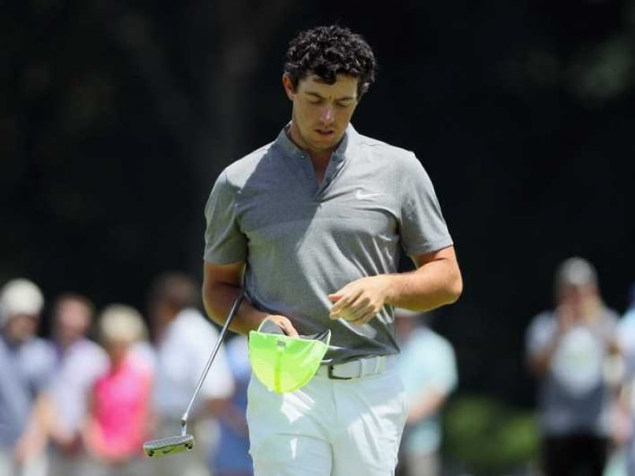
2015 saw him card his first top five at Augusta, and despite the emergence of Jordan Spieth as a Masters menace, he was getting closer. After two more years of top ten finishes in 2016 and 17, he got himself into the final pairing in 2018, where he mounted an early charge at leader Patrick Reed before coming undone with three bogeys on the front nine. The next year he would kick off the tournament with his worst opening round since 2010 and was unable to even crack the top 20. Poor opening rounds would become a theme for McIlroy over the next half decade.
Now five years removed from his last Major, the pressure had begun to build not just to complete the grand slam, but to win anywhere. Despite consistently winning on the PGA Tour, Rory McIlroy was fading under the pressure of the Major Championship tests. To make matters worse, Brooks Koepka had just tied his Major total and finished runner-up in two other Majors. McIlroy now had to face the possibility that he not only might never win another Major, but also that he wasn’t even the best player of his own generation anymore, something that seemed like a foregone conclusion just a few years prior. With the pressure continuing to mount, the 2020 and 2021 Major Championship seasons with just three total top tens, none of them competitive.
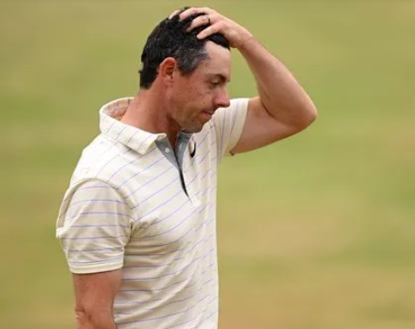
2022 saw McIlroy step out of the wilderness and begin what I would deem his ‘heartbreak era’. Despite not being in contention, a stellar final round 64 at the Masters earned him a solo second place finish, with McIlroy saying it was the best feeling he’d had leaving Augusta in his career. He held the solo lead after the first round of the PGA Championship but would eventually stall out to finish T8. The Open Championship that year would be played at St. Andrews, a potential fairy-tale ending to the Major draught. Unlike many previous Majors, McIlroy got off to a hot start in this one, with an opening 66 to sit in solo second. He followed that up with a 68, and despite being three shots back, was in excellent position. Another 66 gave him a share of the lead coming into the final round, with him and Viktor Hovland four shots up on the competition. In a final round which everyone assumed would be a two-horse race, Hovland and McIlroy struggled. Rory managed only two birdies on a day where everyone else was going low, and by the 18th hole he had lost the lead to both Cam Smith and Cameron Young. This was the most heartbreak McIlroy had felt since the 2011 Masters, and despite playing disciplined golf to avoid some of the big mistakes he had made in previous Majors, he ultimately played things too safe.
His next real opportunity would be the 2023 US Open at LACC where he again got off to a good start, sitting T5 after the first round. Two more disciplined rounds had him entering the final round alone in third, one shot back of the leaders. He opened with a bogey to tie the lead, but much like St. Andrews, just treaded water for the rest of the day, failing to make another birdie. In the end, he would lose by one shot to Wyndham Clark.
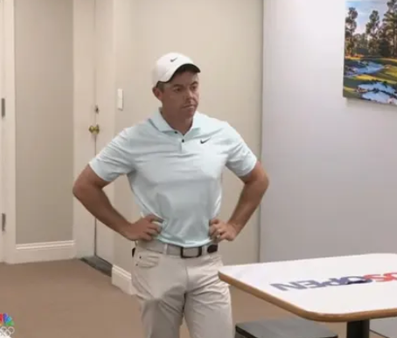
The US Open now seemed to be Rory’s best chance at snapping the Major Championship draught, as he had carded five straight top tens there, steadily progressing from T9 to his solo second in 2023. The 2024 US Open at Pinehurst set up well for Rory, and like the last few times he contended, he started off well, tied for the lead after the first round. However, like previous attempts, he couldn’t follow it up with another good round, finding himself two back in T5 after the second round. A bounce back 69 would get him within three of the lead to start the final round, and with four holes remaining, he found himself in solo possession of the lead. Unfortunately, the pressure got to him, and he bogeyed three of the last four holes, including a missed putt from just a couple of feet above the hole on 18. To add insult to injury, Bryson would get up and down from 50 yards, leaving his putt on the low side and making the putt McIlroy should have left himself to win while he looked on from the scoring tent.
With all that baggage and eleven years of pressure to win both another Major, and complete the career grand slam, Rory McIlroy somehow came into Augusta as the favorite. Despite the heartbreak, he had played some of the most complete golf of his career in the previous few years, developing aspects to his game that he lacked previously. Spin control and the ability to flight his irons lower was exemplified in his Players Championship win, when he hit a knockdown 9-iron on 17, a hole where JJ Spaun’s stock tee shot would fly the green into the water. With so many false fronts at Augusta, spin-control is crucial.

The 2025 Masters

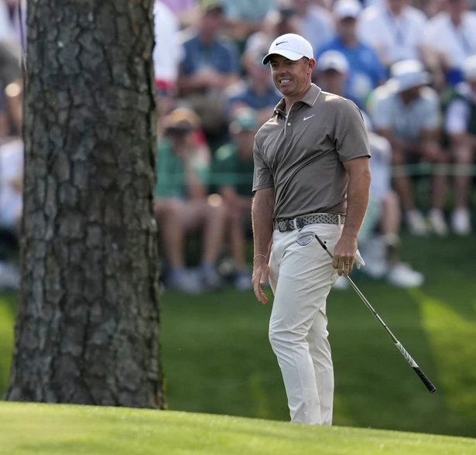
Over the previous six Masters, Rory was able to break par in the opening round just once, with none of them in the sixties. The first order of business would be getting off to a good start. Conditions were tough on Thursday, but Rory took a measured approach and played smart golf until 15. Over the green, he failed to gauge the speed correctly, chipping over and into the water. A lazy recovery shot lead to a double bogey, and another lazy approach and three putt on 17 resulted in another double. All the progress he had made over the round was wiped out in the last four holes, finishing the round at even par. Despite the disappointment on Thursday, McIlroy showed resilience on Friday, carding a bogey-free 66, including a long iron that JUST cleared the creek on 13 to set up an eagle. The mistake-free round set him up two back going into moving day. And what a moving day it was! Starting off the round on absolute fire, six straight threes to start the round snatched the lead, and despite a mid-round slump with a couple of bogeys, he bounced back well with an all-timer midiron into the 15th green to set up an eagle. When the dust settled, McIlroy would take a two-shot lead into the final round, his best chance to win The Masters since 2011.

The Final Round

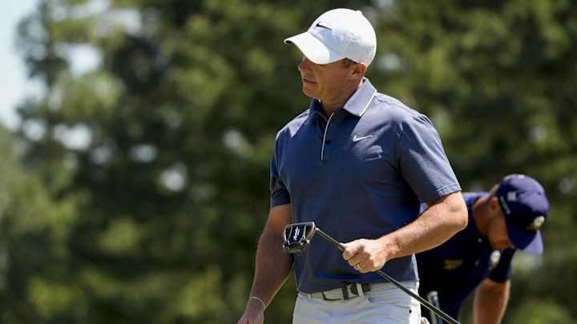
The final round of the 2025 Masters honestly deserves its own book, but we’ll do our best to summarize one of the most captivating, exhausting, unbelievable rounds of golf of all time. To start, McIlroy would be in the final pairing with Bryson DeChambeau, the man who ripped out his heart just 10 months prior. Corey Conners would start four back of McIlroy, with Patrick Reed and Ludvig Aberg six back. A true dual between McIlroy and DeChambeau. The first hole started with McIlroy pushing his tee shot towards the bunkers on the right, but unlike the previous day when he sailed over them, he fell about a yard short this time. With an awkward stance, he just had to lay up, leaving a wedge which he sailed long of the back pin. He three-putted from there and the lead was gone after one hole. The second hole wouldn’t be much better, again failing to clear the bunker by about a yard, which lead to a layup, poor wedge shot, and two-putt par. Bryson now held the solo lead and things were starting to slip away.
Stepping up to the third hole, Rory would need to do something to change the momentum. McIlroy kicked into gear and birdied both, with a delicate approach shot on three, and a towering long iron to nine feet on four, one of the best of the day on that hole. Bryson was unable to dial in his yardages on either hole, leading to a pair of bogeys and a four shot swing. The lead was now up to three.
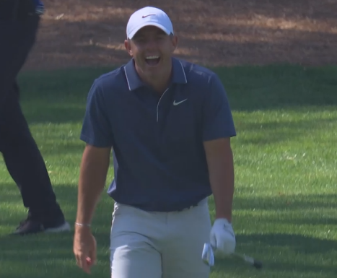
After a pair of stress-free pars on five and six, McIlroy found himself in a tight spot on seven, in the trees with a small window. He swung all out on a wedge which seemed to hang in the air forever before coming to rest just eight feet from the pin. That would be the first of four incredible shots hit during the round. Despite leaving the putt short, he was still comfortably in front, with Bryson struggling to make anything happen.
After another scratchy par on eight, Rory would turn on the jets on nine and ten, playing six perfect shots to birdie the pair. Another two pars from Bryson officially shifted the tone of the tournament from a duel, to Rory’s to lose.
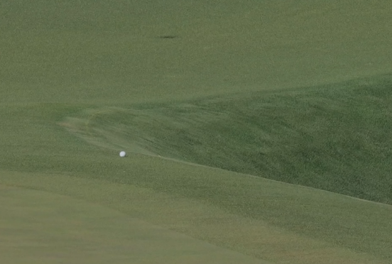
The nerves seemed to hit McIlroy again on 11, as he pulled his tee shot. They say you need a bit of luck to win Major Championships, and Rory got some here. His approach kicked hard left off the mounds right of the green, rolling towards the pond before coming to a stop around a foot short of rolling in. Despite the lucky break, McIlroy was unable to make par, but with Bryson doubling to fall back to seven under par, it seemed he was out of the tournament.
While the leaders struggled to keep things going through Amen Corner, the roars were erupting from elsewhere on the golf course. Patrick Reed had earlier birdied six, seven, eight and nine. Scottie Scheffler birdied 12 and 13, and Justin Rose birdied 11, 12, and 13 to reach 10 under par. With Bryson out of contention, Rory had slayed one of the demons from the 2024 US Open, but hanging onto the lead on the back nine was the next one up.
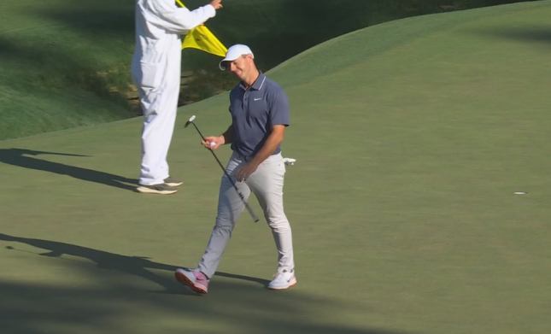
After a tidy par on 12, McIlroy came to 13 with a noticeably more conservative strategy than prior rounds. A three wood off the tee, and layup short of the creek is the prudent play, but not what had gotten McIlroy this far in the tournament. Unthinkably, he pushed the wedge shot right of the hole into the creek, with miles of space to the left. His fourth double bogey of the week now placed him in unprecedented territory, as no one had ever won The Masters while making that many before.
With just a one-shot lead now on the 14th, he pushed his tee shot right, left his approach shot short of the green, and failed to get up and down. For the second time in the round, he had lost the lead.
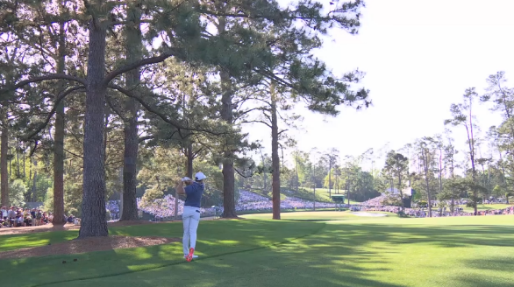
Stepping up to 15, he pulled his tee shot, and while he was still in the fairway, the trees that protrude from the left blocked his view of the green. Now trailing by one and in the position of needing to make something happen, he pulled six iron, aimed at the grandstand on the right and hit another of the most incredible shots of his career. A towering draw around the trees came to rest six feet from the pin to set up an eagle. As had troubled him throughout the round though, he missed the six-foot putt and had to settle for birdie and a share of the lead.
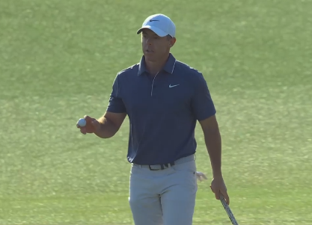
A solid tee shot on 16 saw him again unable to convert from nine feet, and he stood on the 17th tee still with a share of the lead. His tee shot in the fairway, but nearly 200 yards from the green, he striped another perfect iron, just clearing the bunker and settling just two feet from the pin. With the tap in made, he came to 18 needing just a par to win the tournament and complete the Grand Slam.
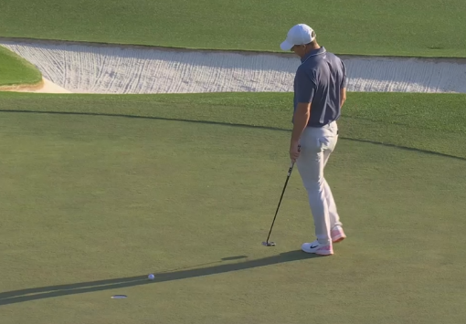
A perfect tee shot leaving just 124 yards, hit the right part of the green and you can enjoy the walk up 18, but we don’t love Rory because he makes things easy. Pushing his approach to the same spot in the bunker he holed out from in 2022 left some hope of a repetition, but his bunker shot settled five feet short of the pin. Five feet to win The Masters. By now you all know where this is going. The putt never had a chance, and for the third time he lost the solo lead. Dejected, he would now need to win a playoff against Justin Rose, who had just carded a 66 and was coming off a massive 20-foot birdie putt on 18 in regulation.
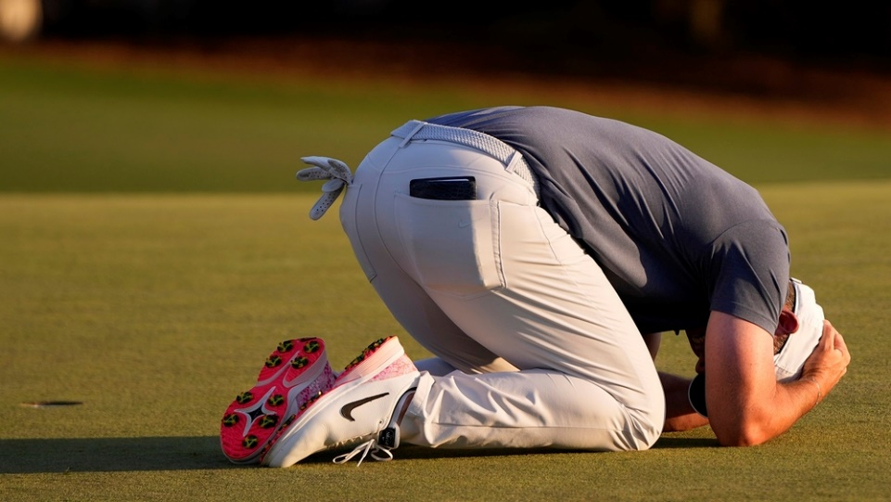
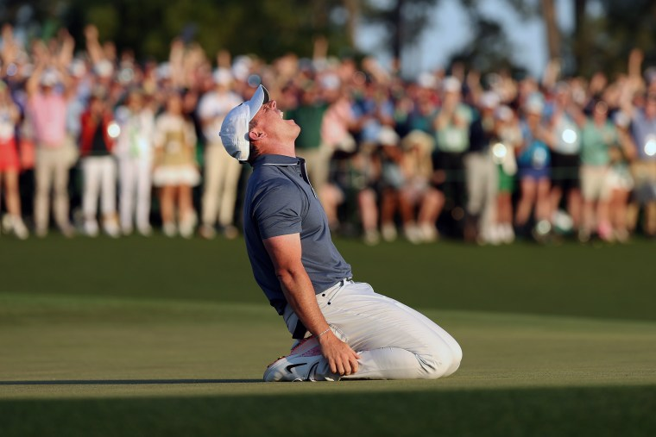
On both the tee shot and approach, Rose went first, putting the pressure on McIlroy. After a solid tee shot from Rose, Rory put his in nearly the same spot as regulation. Another demon to overcome. Rose’s approach would leave him with a relatively straightforward 15 foot putt for birdie, shorter than the putt he made in regulation. Pressure back on McIlroy. With the previous approach fresh in his mind, Rory stepped up and yet again hit an unbelievable approach, leaving just four feet. Rose was unable to make his putt, leaving Rory one just slightly shorter than the putt he had in regulation. He made it.

Resilience
Over the past couple of years, Rory McIlroy has talked a lot about resilience, and what it means to him. Since he was a teenager, he’s had the pressure placed on him of being ‘The next Tiger Woods’. For a short time he lived up to that billing, but it was always an unachievable expectation. Since his collapse at the 2011 Masters, he’s had to deal with the pressure of not only overcoming that heartbreak, but the pressure placed on him by legends of the game like Jack Nicklaus and Tiger Woods saying he would win one. By 2014, his performance in Major Championships set a standard that meant for every single Major Championship he didn’t win, the pressure would build more and more for the next one. And all of that added to the pressure of eleven missed opportunities to win the career Grand Slam, an achievement we’ve seen just twice in the last sixty years.
All of this compounded and made each Major Championship heartbreak that much more crushing. And yet he still believed he could do it. His final round in the 2025 Masters is a fantastic example of the resilience he’s expressed is so important to him. To lose the lead three separate times. To conquer the demons of your 2024 US Open loss to Bryson, only to realize that wasn’t the final boss. To have the Grand Slam on your putter, miss the putt, and bounce back with three perfect shots in the playoff.
I’ll be the first to admit that I lost faith he would do it. Every Masters, every Major there is the internal conflict of “Well maybe this time it’s different” and it never was. Then this Sunday, I got to the same point of believing he’d blown it again. But unlike past tournaments where he’s fallen off, he stepped up and got himself back in it. The birdies on three and four, the approaches on 15 and 17, and finally, the birdie in the playoff. To see the weight of a decade of expectations lift off someone’s shoulders is fascinating, and I truly believe we’ll look back on the 2025 Masters as not just one of the greatest triumphs in golf, but in all of sports.

